1. First of all, create a directory called “html”.

2. Open terminal to create a local python server

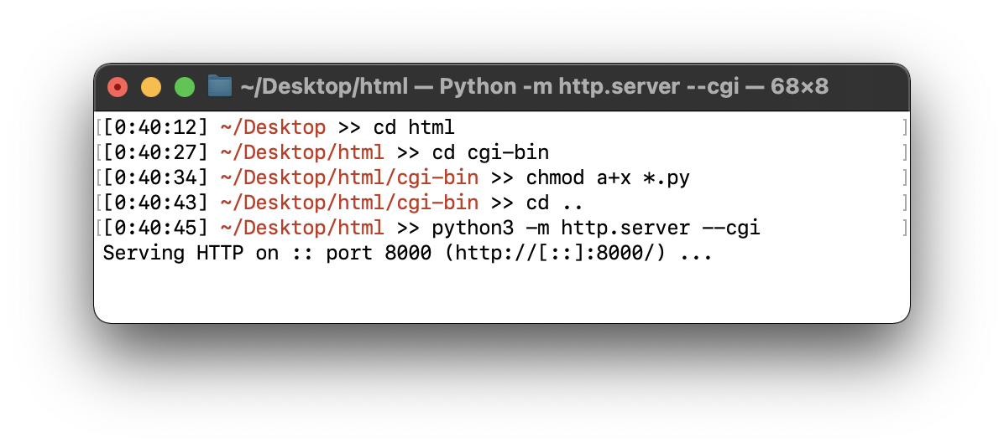

3. Open another terminal to access mysql database,

4. Type this command: mysql -u root -p

5. After you login as root, create a database called “JUKEBOX”,

CREATE DATABASE JUKEBOX;

6. And create a table called “TRANSACTION”,

CREATE TABLE `TRANSACTION` (

`song` varchar(10) DEFAULT NULL,

`cc_number` varchar(20) DEFAULT NULL);

7. Now we have an empty table,

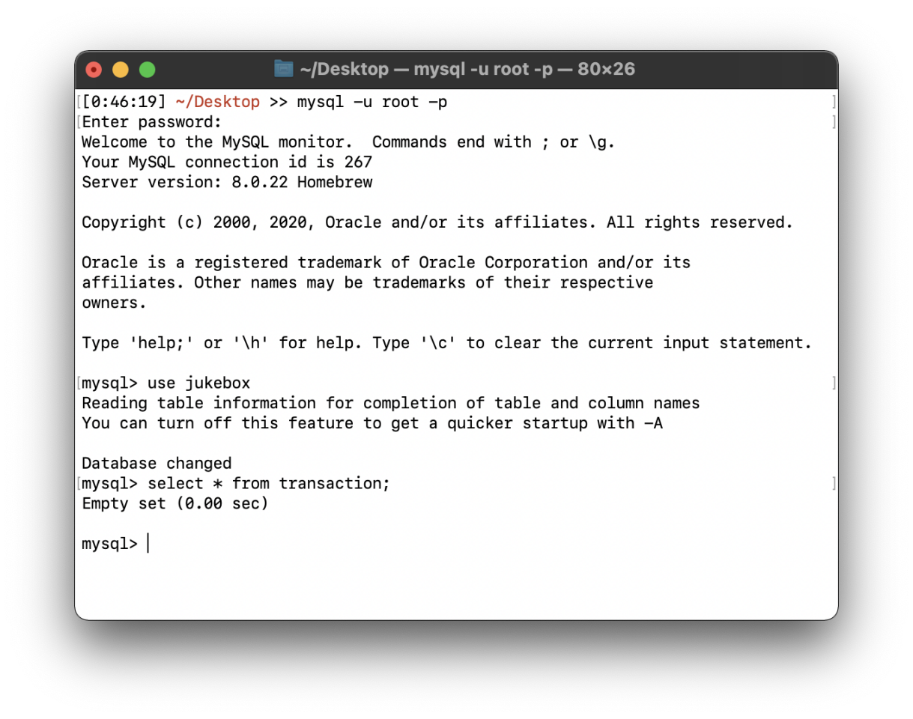

8. Then go to your browser to the URL”127.0.0.1:8000”, you will see this page

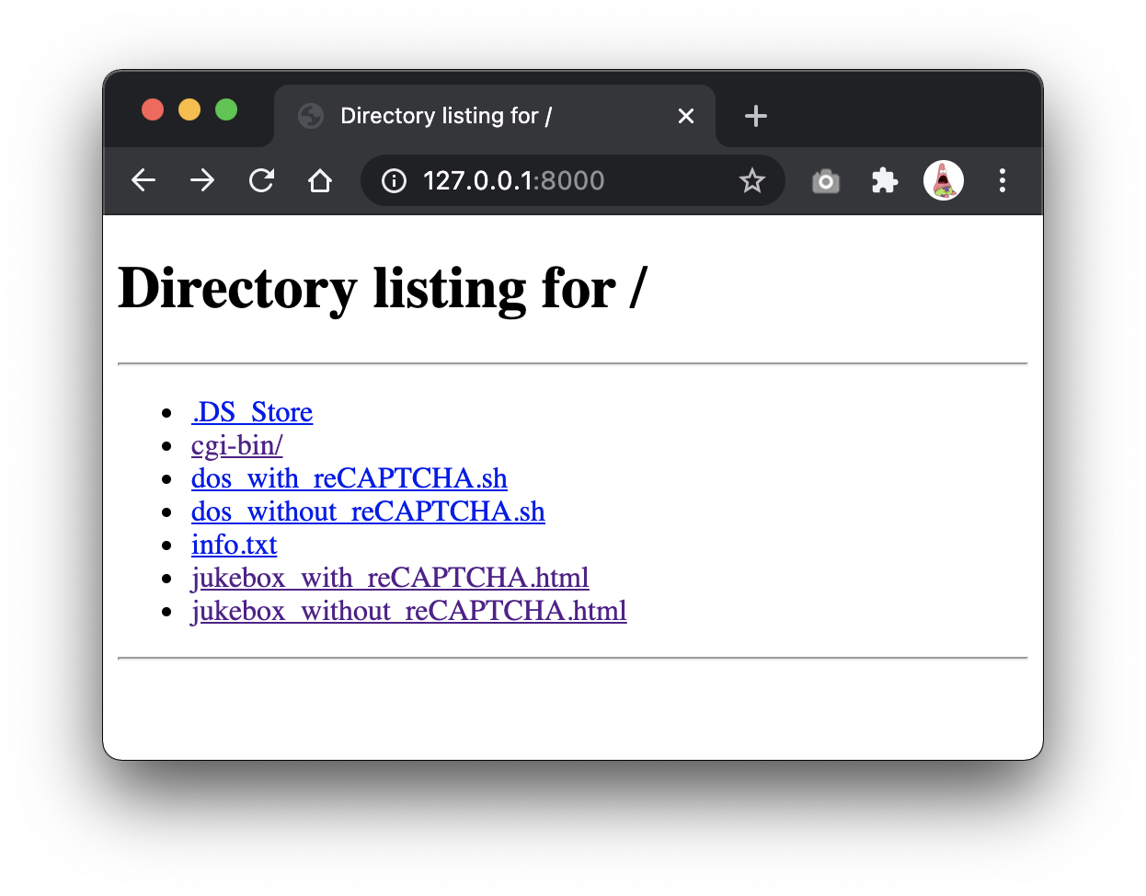

1. Click jukebox_without_reCAPTCHA.html file, you will see the jukebox form.

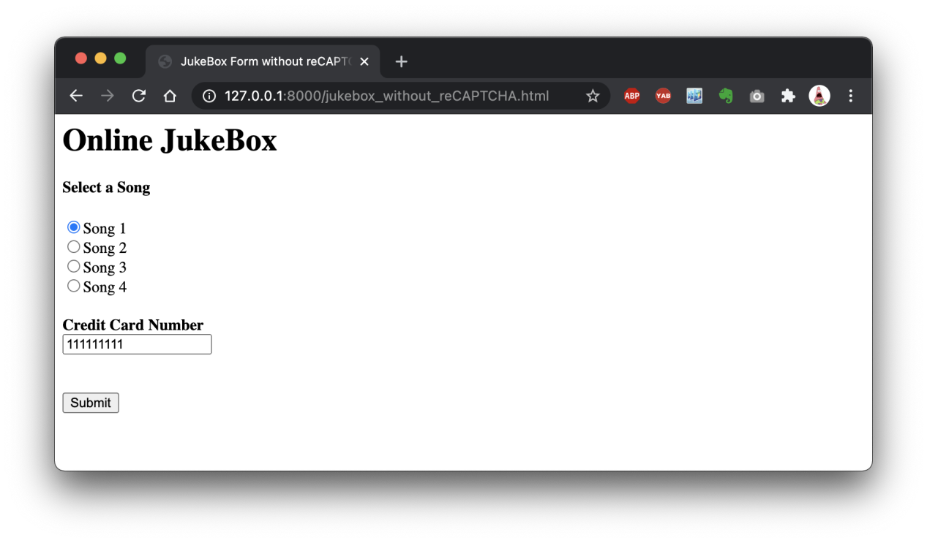

10. After you select song number, type your credit card number and press submit, it will display your information like this.

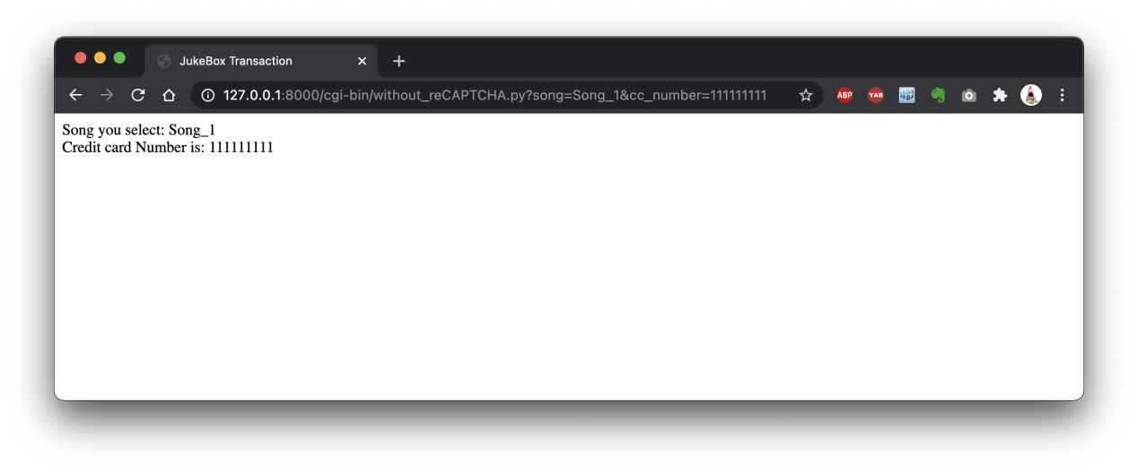

11. Now go to your database, your information stored successfully.

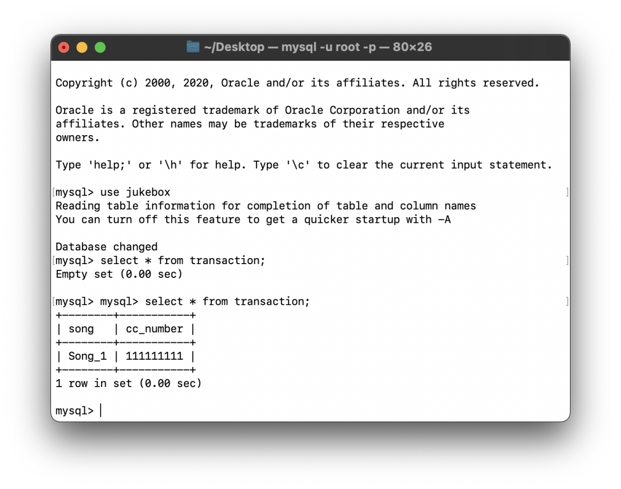

1. Run “bash dos_without_reCAPTCHA.sh” to conduct a DOS Attack.

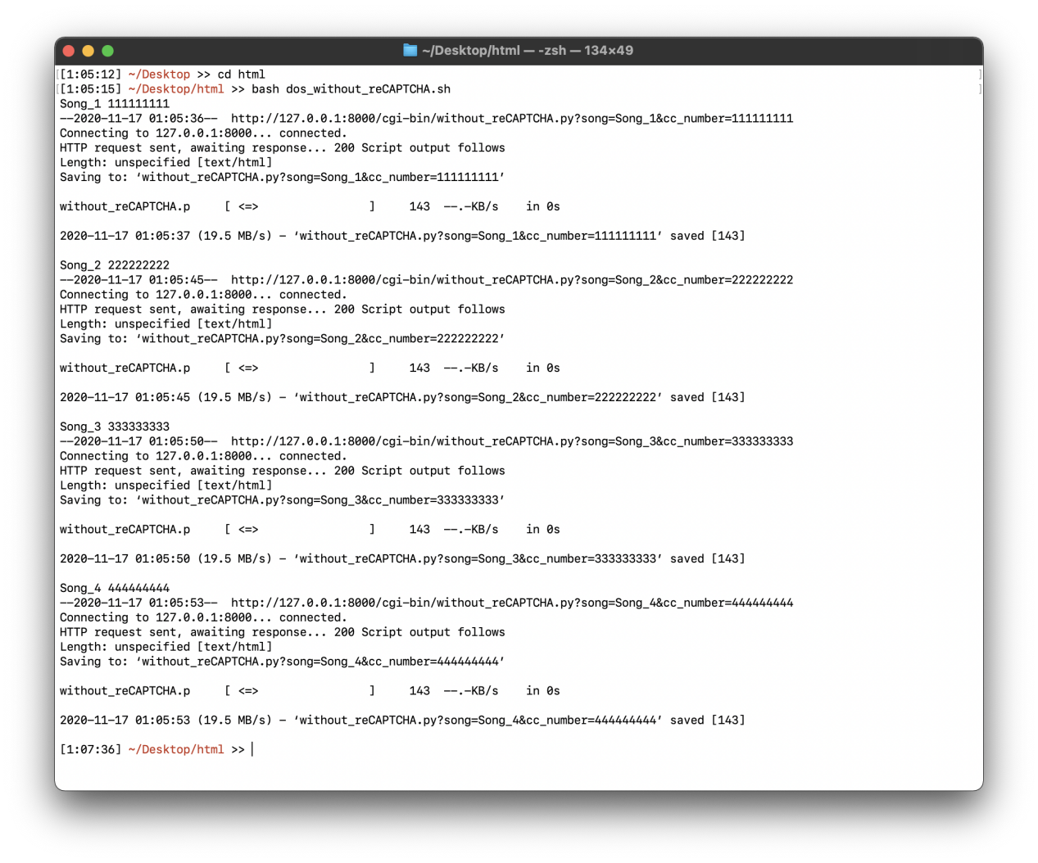

13. Shell script automatically read song number and credit card number from info.txt and fill this jukebox form.

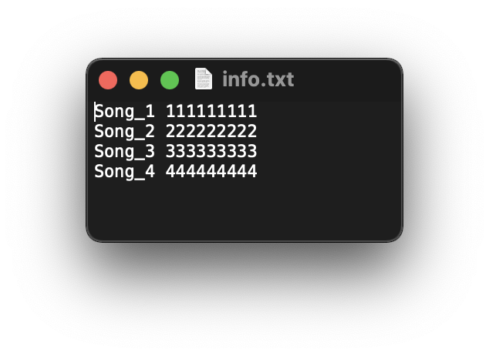

It’s clearly to see it’s easy to be DOS attacked for some simple web forms.

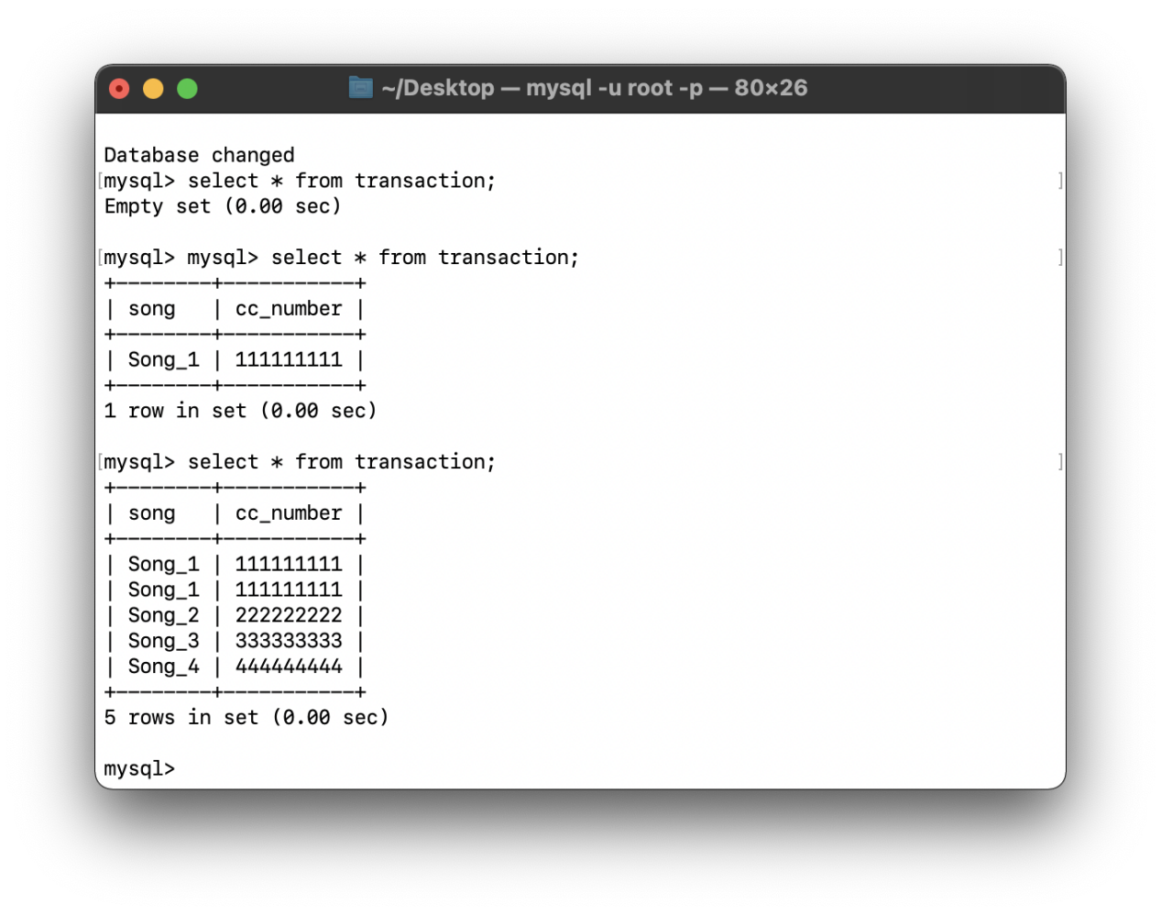

14. Let’s add reCAPTCHA to prevent from DOS Attack:

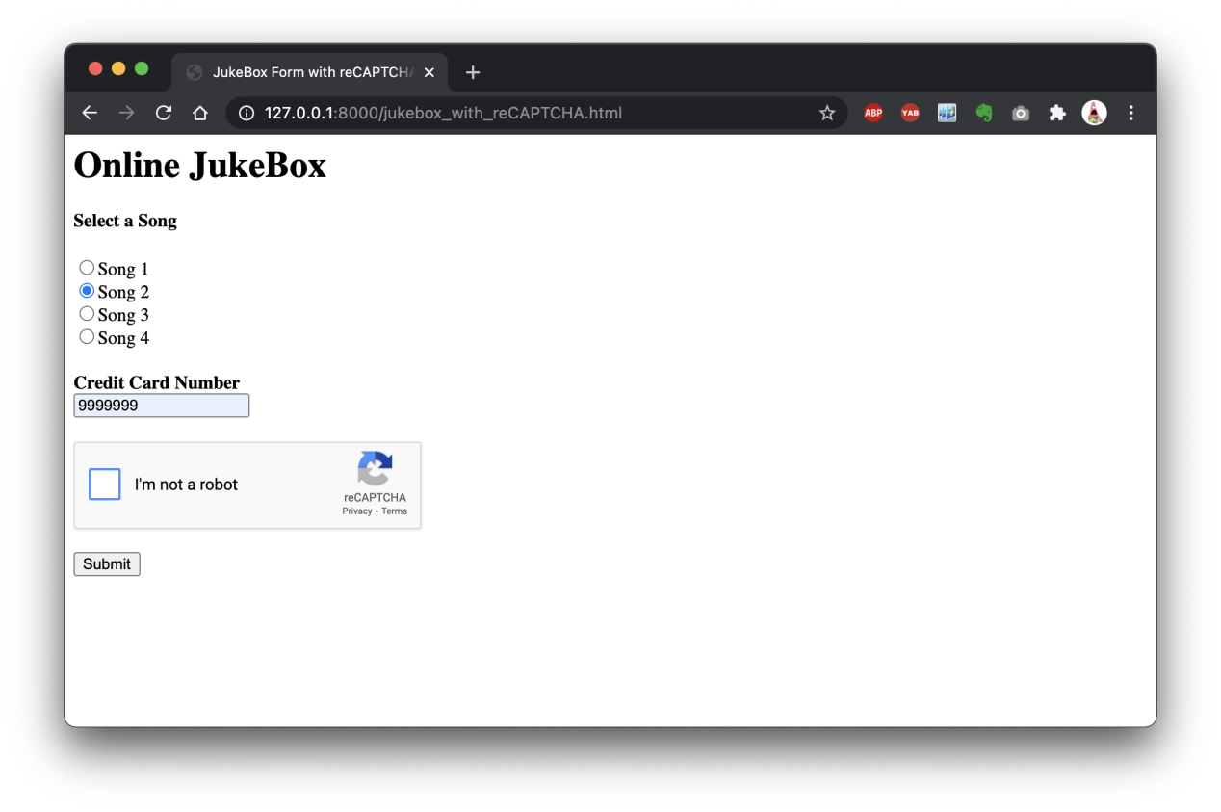

15. You have to pass the reCAPTCHA verification to make sure you are not a robot.

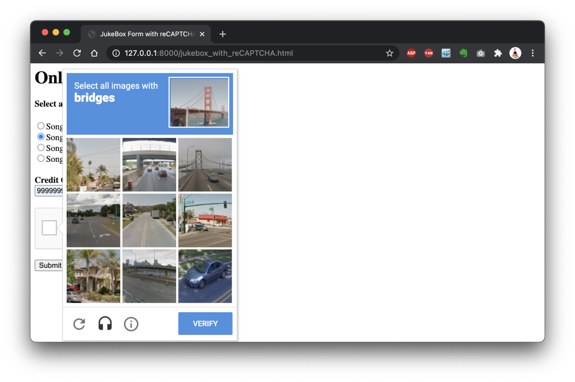

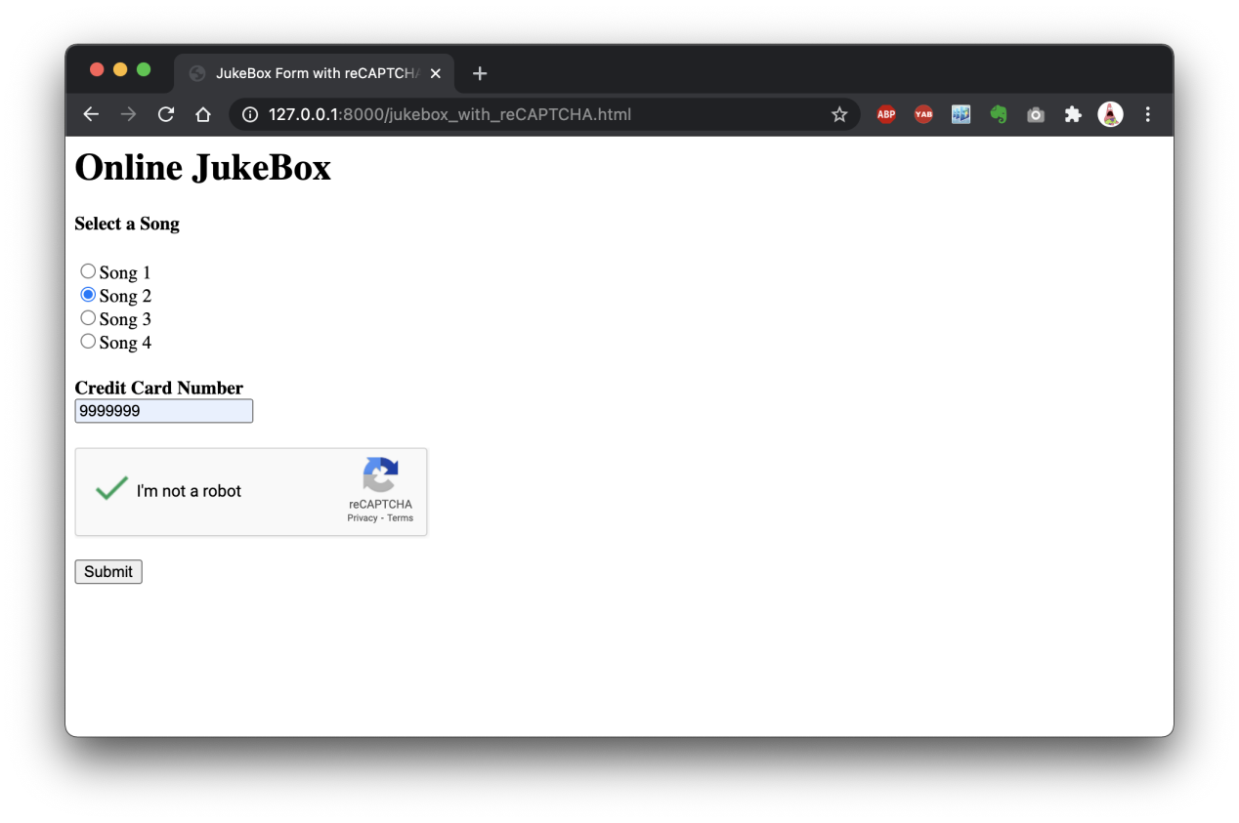

16. It tells you reCAPTCHA succeed. Now your form has been stored to database.

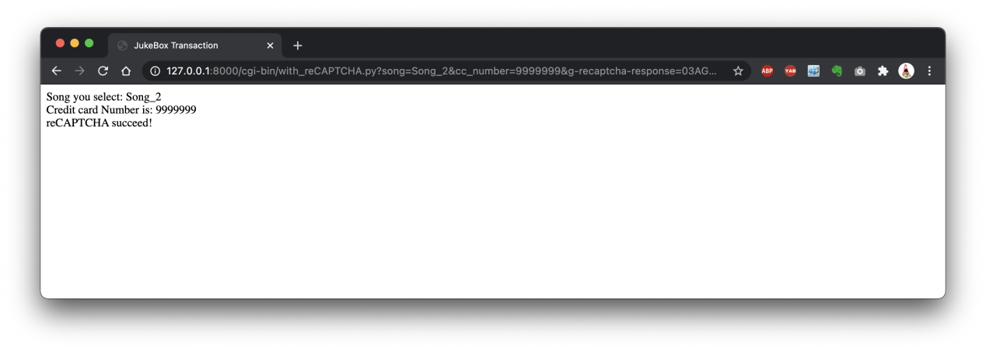

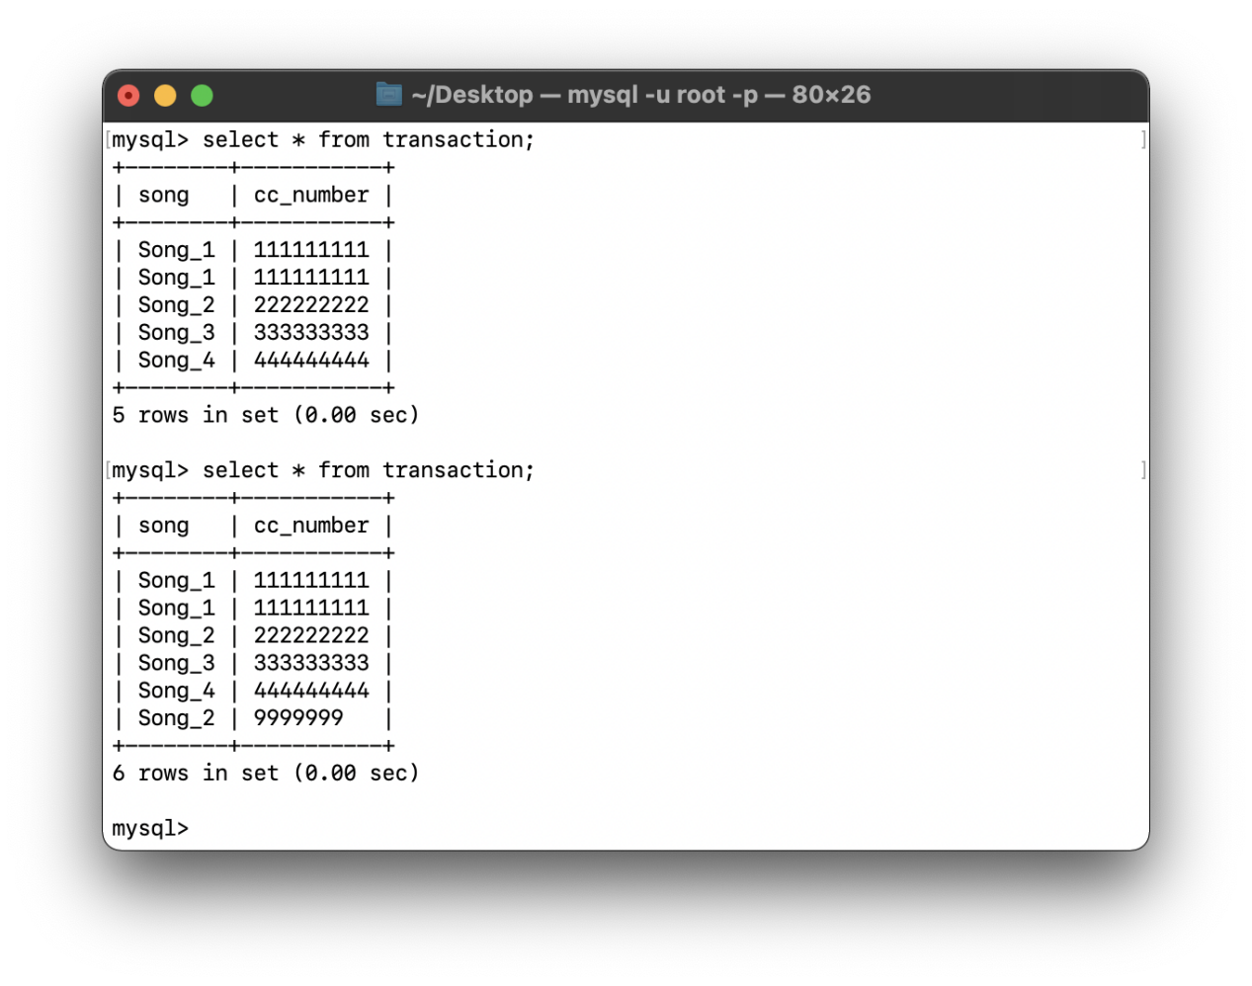

17. Now, let’s try DOS attack one more time.

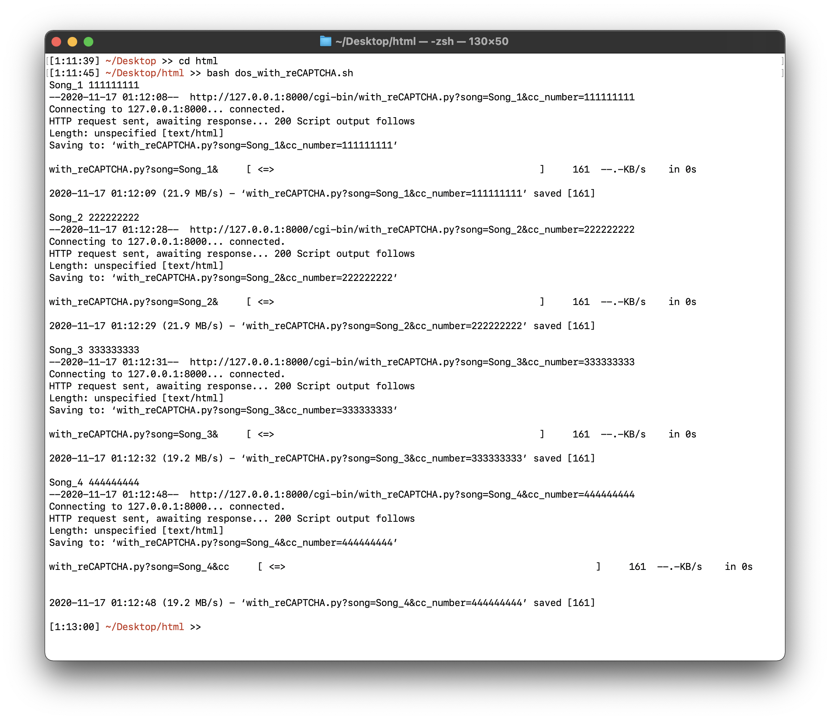

18. It tells you reCAPTCHA failed.

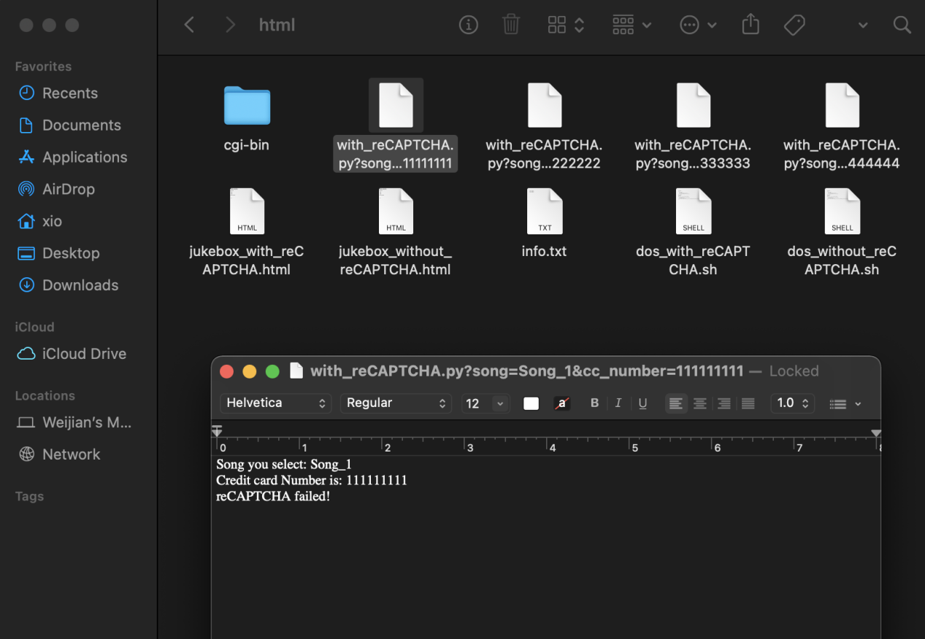

19. And database didn’t allow any new data modification from DOS attack

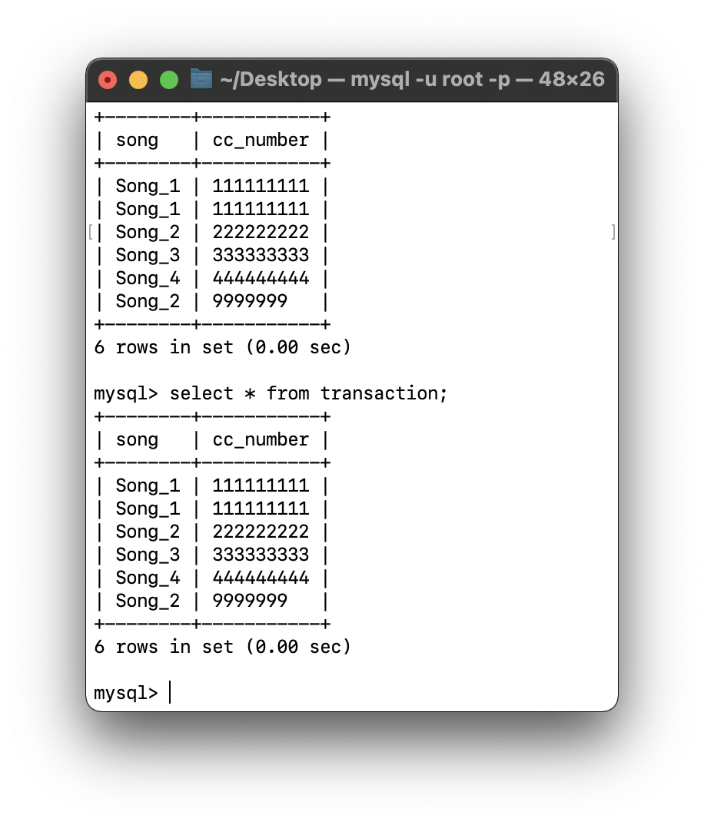

1. reCAPTCHA prevents you from DOS attack !!!

**Register reCAPTCHA:**

<https://www.google.com/recaptcha/admin/create>

If you use local server, add “127.0.0.1” and “localhost” to your domains.